SQL TEST

1. SQL Query to fetch records that are present in one table but not in another table.
2. SQL query to fetch all the employees who are not working on any project.
3. SQL query to fetch all the Employees from EmployeeDetails who joined in the Year 2020.
4. Write an SQL query to fetch only odd rows from the table.
5. Write a query to select all employees' names and roles along with the name of their department. Assume departments are in a table called Departments (DepartmentID, DepartmentName) and employees are in Employees (EmployeeID, Name, Role, DepartmentID).

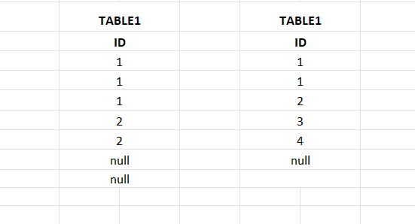

Write only the numbers of rows fetch in each joins?

1.Inner join

2.left join

3. Right Join

4. full join

5. Cross join

6. Natural join